Dear colleague,
Since 2020, the scientific and practical journal PULMONOLOGIYA has switched to the international standard for electronic document workflow and accepts manuscripts for consideration ONLY VIA THE JOURNAL WEBSITE.

To send the manuscript to the editorial board, follow the instructions:
- Register at the website (be sure to include your SPIN from eLibrary and ORCID ID).

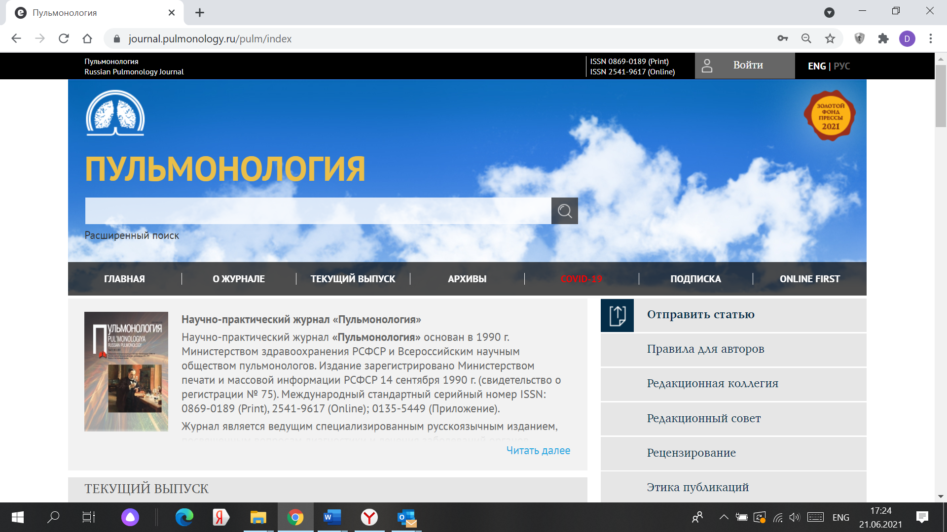

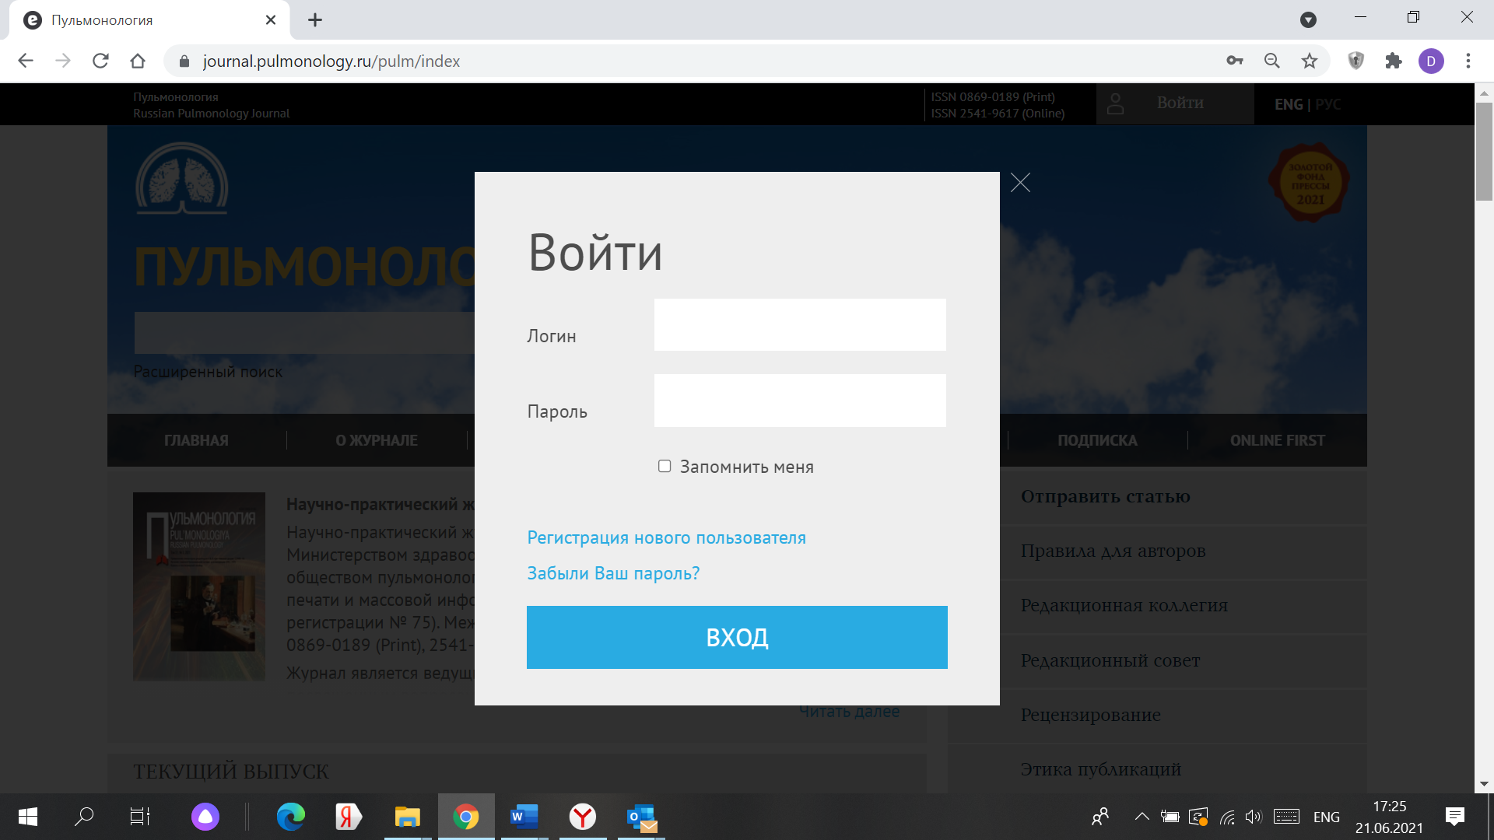

- After filling out the personal data and completing the registration, you will receive login details to your personal account, where you can submit the article.

You can interrupt the submission of the manuscript to the editorial board at any stage, and then continue it at a convenient time in your personal account on the journal’s website. All the information you entered will be saved if you save each completed page of the form.

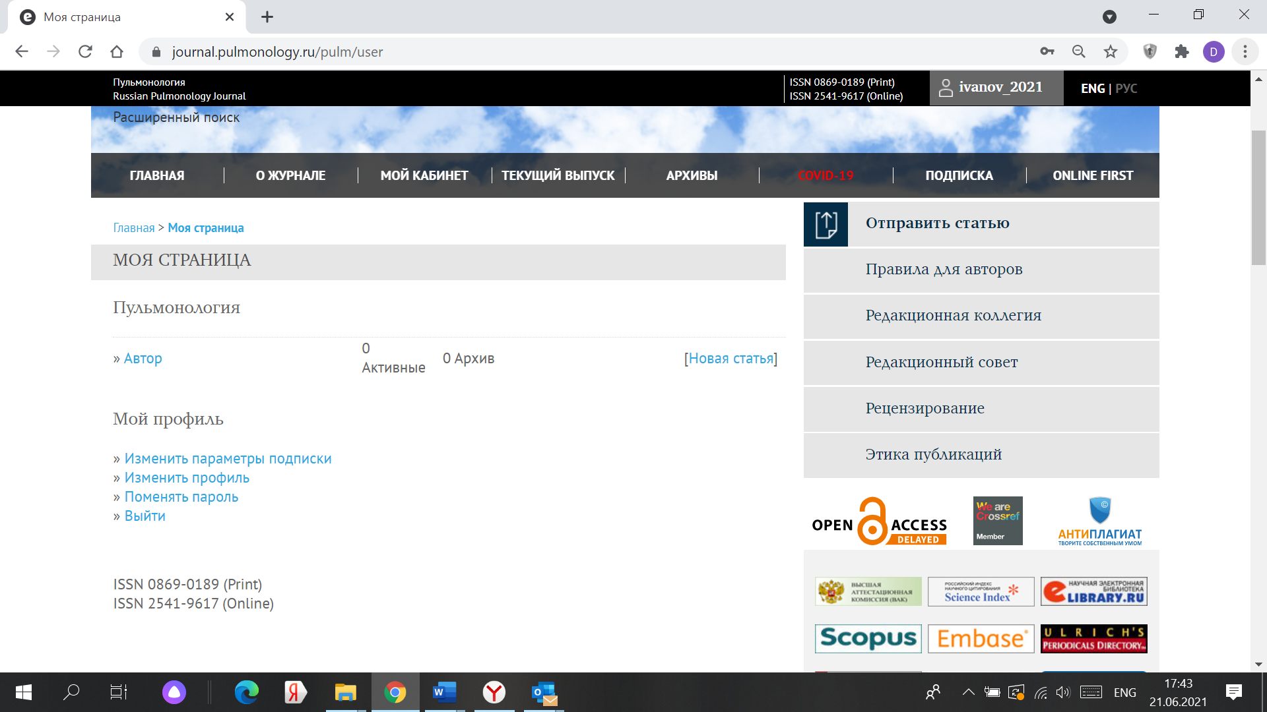

- A. Select the type of publication corresponding to your manuscript in the ‘Journal Section’ field and select the language of the full text of the article in the field ‘Language of the article’.

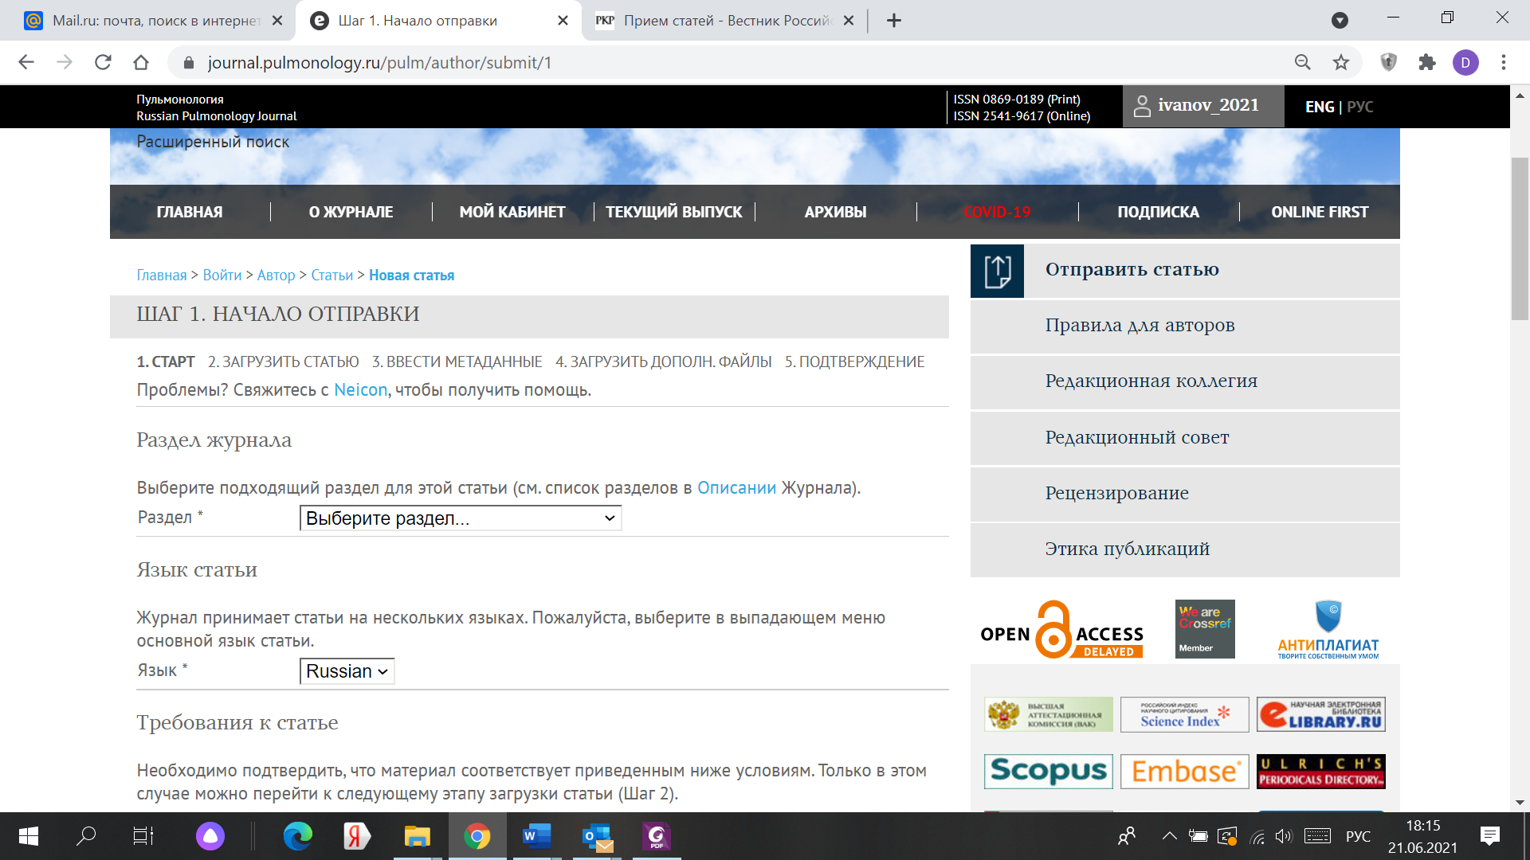

B. Confirm the compliance of your manuscript with the requirements of the journal PULMONOLOGIYA by ticking the appropriate boxes on the same page.

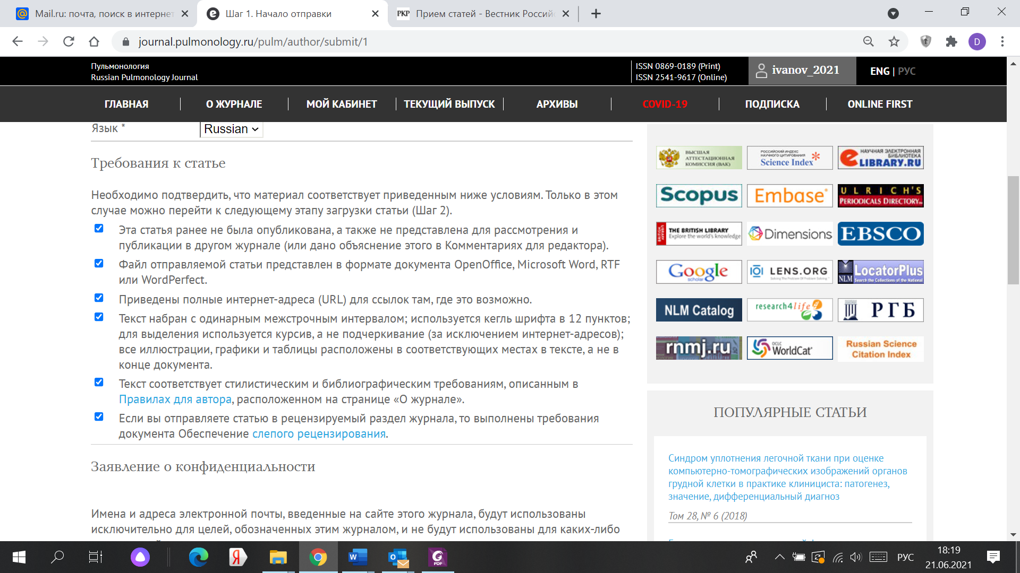

C. Agree to the transfer of copyright in accordance with the terms of the publishing offer agreement.

- The authors retain the copyright and grant the journal the right for initial publication of the work. In 6 months after the publication, the work shall be automatically licensed under a Creative Commons Attribution License (CC BY-NC-ND 4.0), which allows others to redistribute the unaltered work for non-commercial purposes with the obligatory preservation of references to the authors of the original work and the original publication in this journal.
- Conditions of the copyright transfer: The author (authorized person) of the article should copy the Publishing agreement form, fill it out, scan it and upload it in with the Additional Files at the next stage.

D. Notify the editorial board if any aspect requires additional attention. Fill in the ‘Comments for Editors’ field if:
• some part of the manuscript does not meet the requirements of the journal (and justify the noncompliance);
• part or all of the manuscript was previously sent for consideration to another journal (but was not published and is not under consideration by another journal at the moment!);
• the author has supplemental materials to the manuscript which is worth publishing in the electronic version of the journal, etc.
If you do not have the required information about such situations, do not fill in this window.

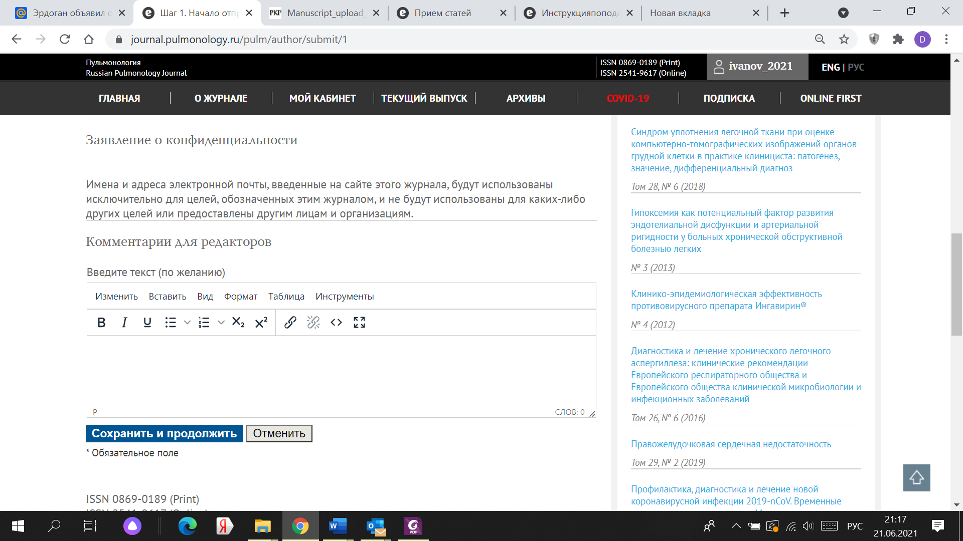

D. Complete this page by clicking the left mouse button on SAVE AND CONTINUE.

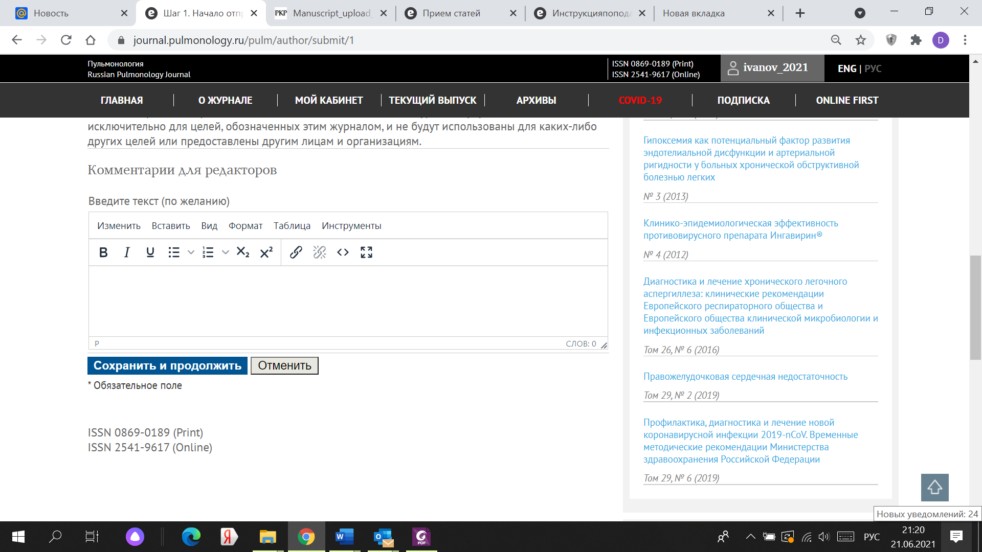

- Go to the second step of submitting the manuscript and upload the manuscript file. Please note that the manuscript must be formatted according to the template and the AUTHOR GUIDELINES.

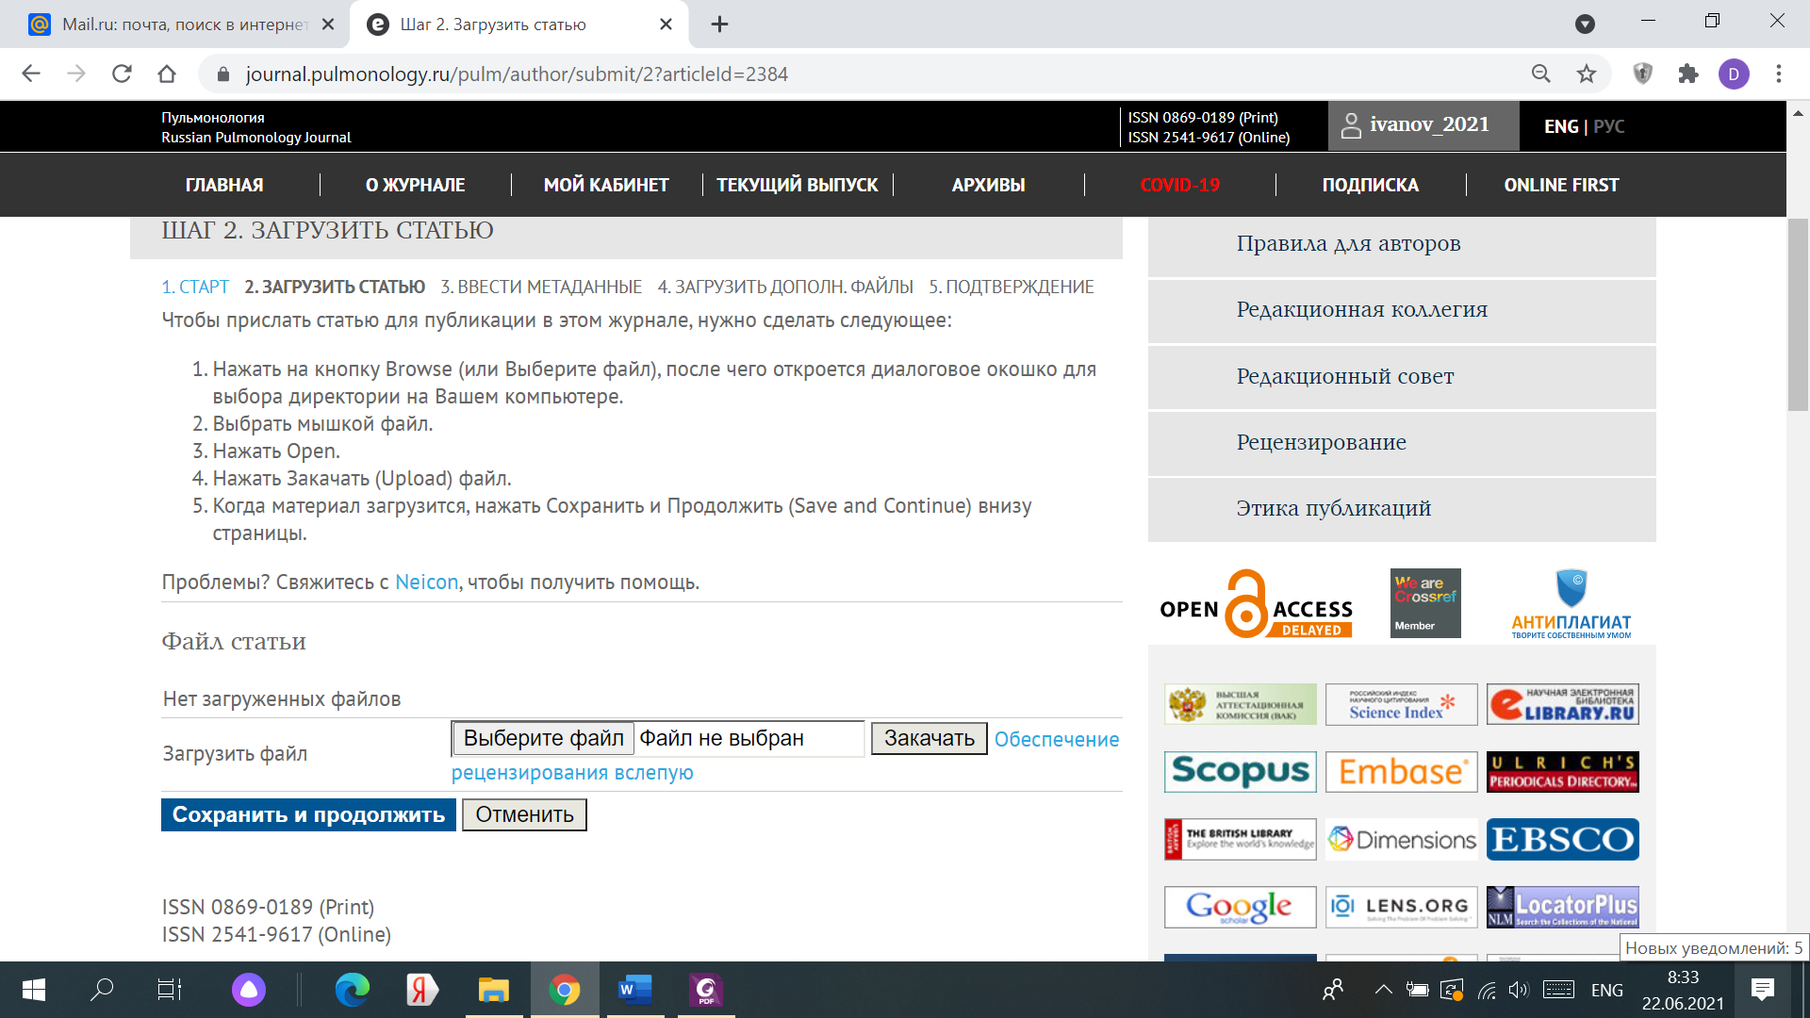

Select text file with the manuscript on your computer and click UPLOAD.
The uploaded file is automatically assigned an editorial number. You will see the text name of the file, its size and date of upload on the page.
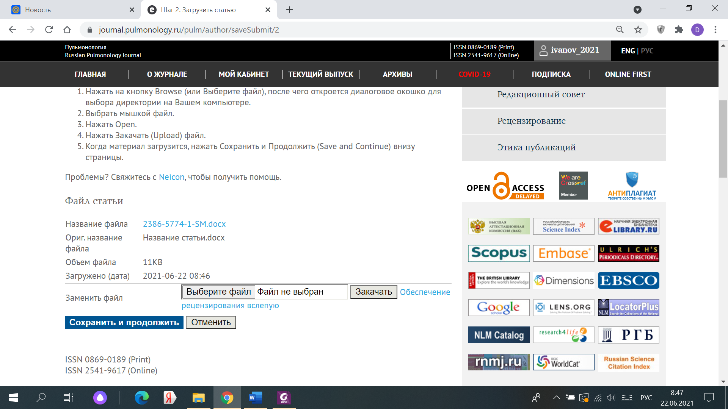
Complete this page by clicking SAVE AND CONTINUE.

- Go to the third step of submitting the manuscript and enter a description of the manuscript. Fill in all the fields (which are applicable) in as much detail as possible. This information will be used in the future when indexing the article in Russian and international databases.
Fill in the information about all the authors of the manuscript by adding them sequentially (click ADD AUTHOR). The authors should be arranged on the website in the same order as they will appear in the article itself.
Please note that you should indicate the full name of the institution (without abbreviations), its jurisdiction, address, and a zip code when filling out the author questionnaire.
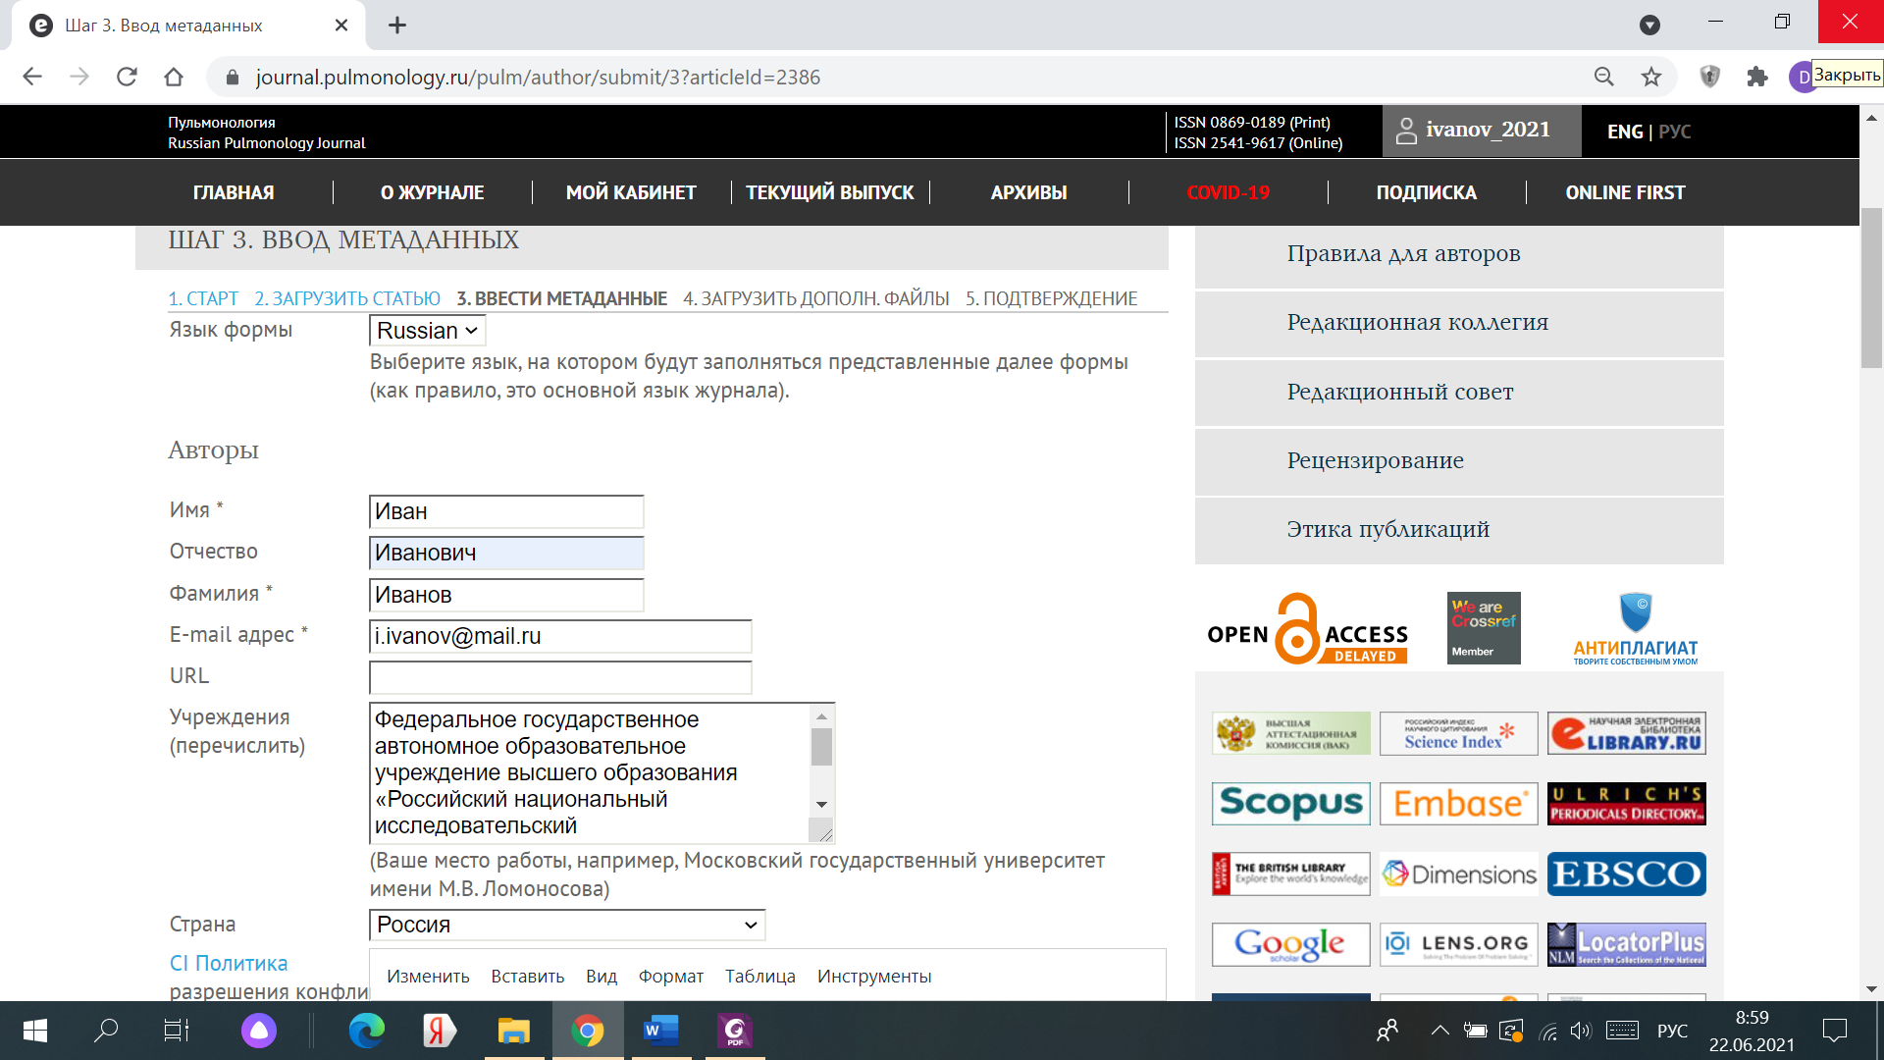

In the field CI policy, describe the conflicts of interest, including the potential ones, for each author during the last 36 months before the submission of the article.
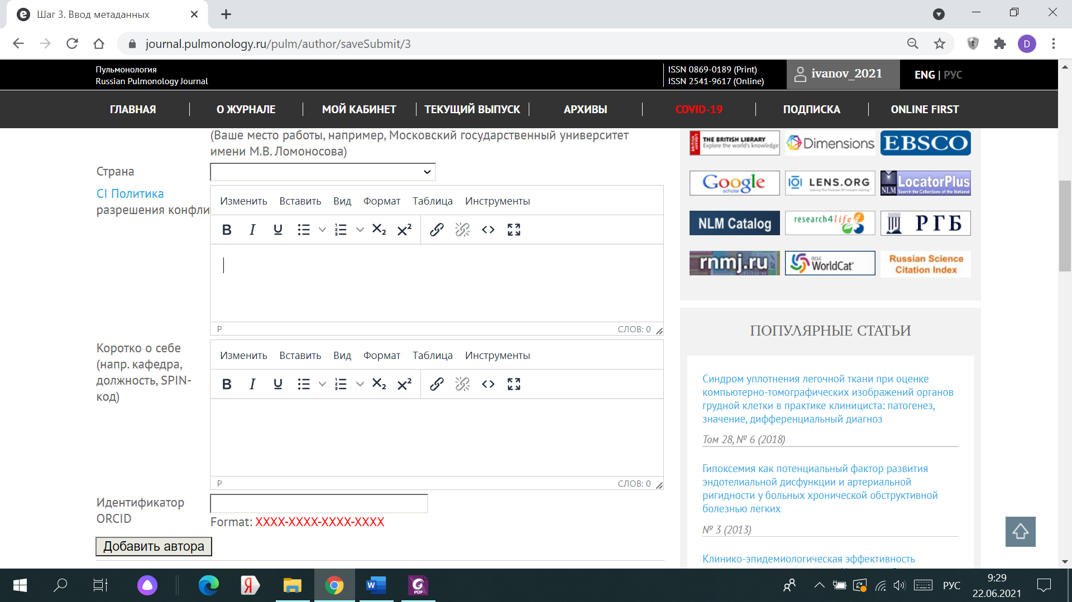
In the “Briefly about yourself” field, provide academic degrees, titles, positions, names of the departments and work phones of all authors. A mobile phone number, along with a work number, and an operational email address is required only for one author, who acts as a contact person for communication with the editorial board. This mobile phone number will not be included in the journal issue.

We recommend that you indicate your ORCID (Open Researcher and Contributor ID) to associate the article will it automatically for the future. If you do not have it for some reason, you can get it easily by registering on the website www.orcid.org.
Copy from the article the article title, abstract, keywords, information about the sponsors of the work (if any), and the list of references and enter these data in the appropriate fields of the form.
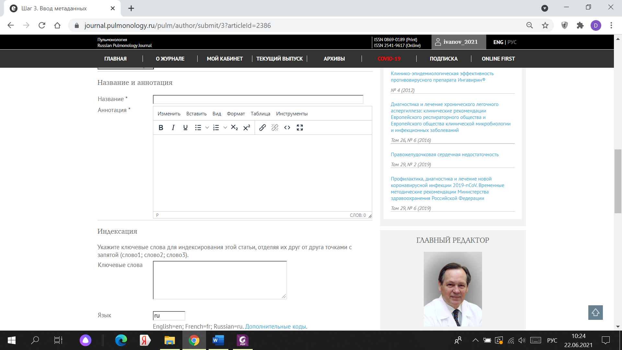
Complete this page by clicking SAVE AND CONTINUE.
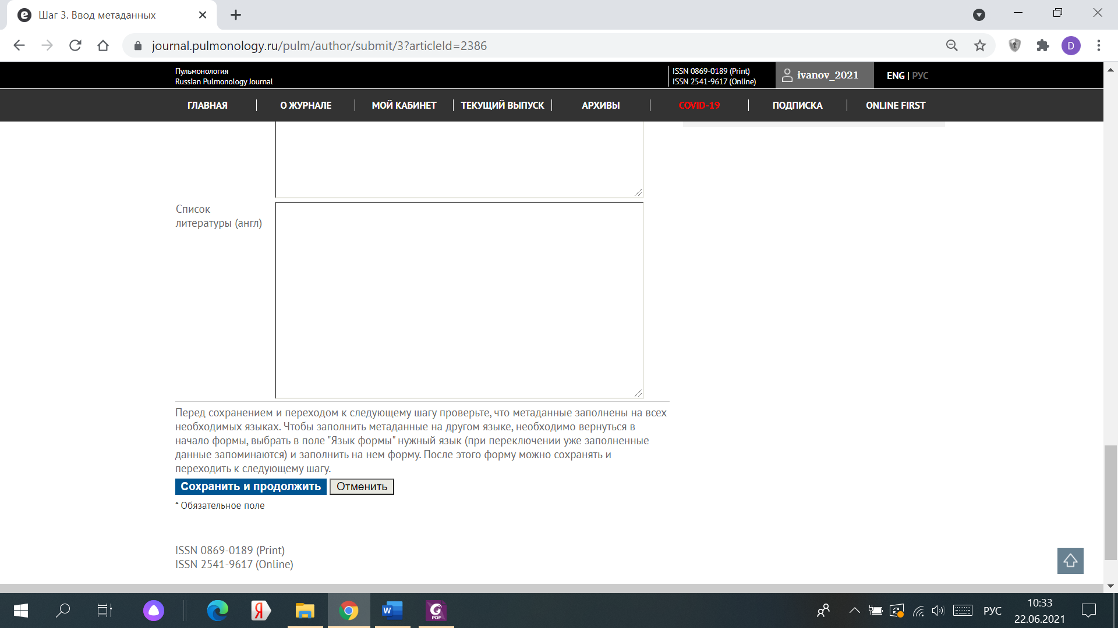

- BE SURE TO FILL IN THE DESCRIPTION OF THE MANUSCRIPT IN ENGLISH (as detailed as in Russian) after filling in the information in Russian. To do this, you need to switch the language of the manuscript description form at the very top of the page. Do not forget to complete this page by clicking SAVE & CONTINUE.
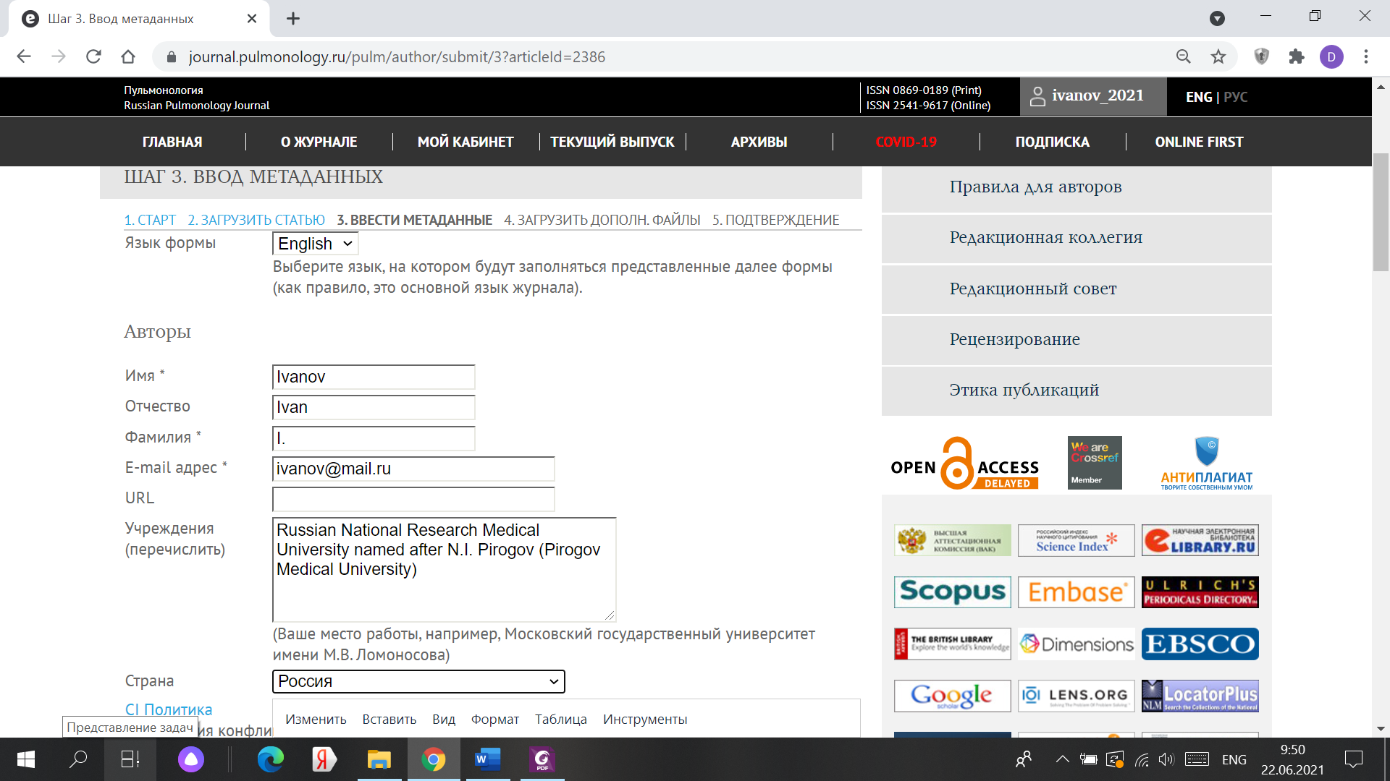

- Proceed to the next step and download additional files (accompanying documents, signed publishing agreement, high-resolution images, additional content). Do not forget to complete this page by clicking SAVE & CONTINUE.

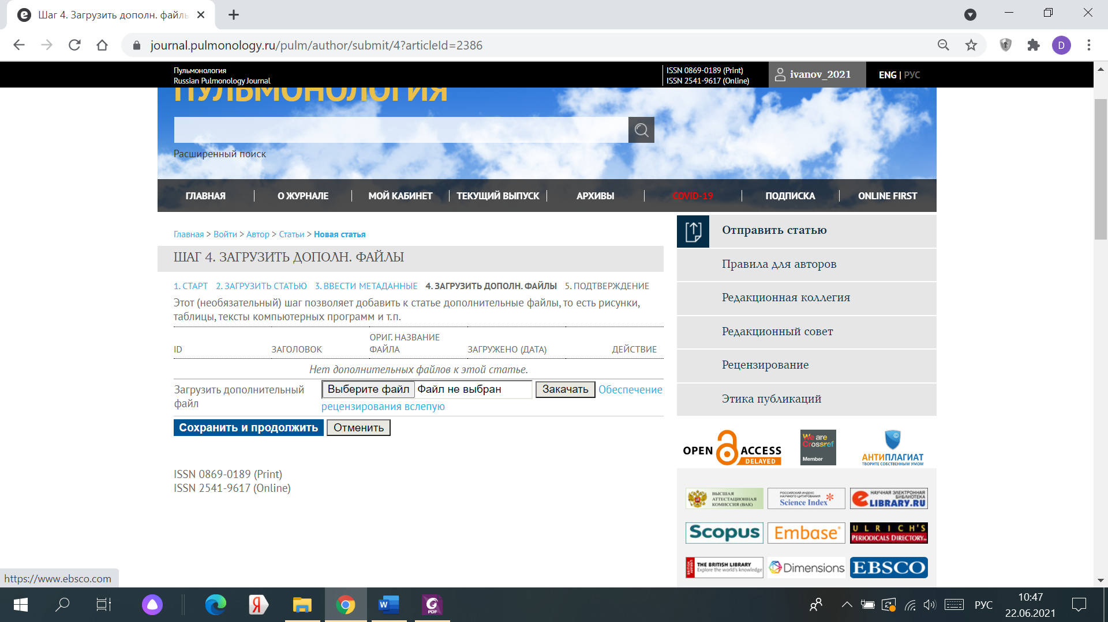

- Go to the next step and check the list of documents sent to the editorial board, then complete the submission of the manuscript by clicking COMPLETE SUBMISSION.
